**YouSpill**

**Analysis and Visualization of U.S. Environmental Protection Agency Toxic Release Inventory**

Group 6 - Ifeoluwakitan Adeyefa, Robert Barnes, Kyle Lund, Jonathan Reksono

CIS4301 – Information and Database Management Systems I

Prof. Alexander Webber

10/14/2024

**Table of contents**

**Page**

Table of Contents 2

Overview and Description 3

Relational Schemas 5

SQL Table Creation 7

**Overview and description**

The U.S. Environmental Protection Agency (EPA) maintains the Toxic Release Inventory (TRI), a vital database that tracks the release of toxic chemicals posing risks to human health and the environment. This project aims to develop a web-based application that will allow users to seamlessly access, query, and analyze TRI data, providing a platform for deeper understanding and engagement with this critical information. The application will also incorporate supplementary data, such as chemical toxicity levels, geographical locations, and relevant political context, enriching the user experience and enhancing the overall value of the information presented.

To ensure robust data management and reliability, the back end of the application will be powered by Oracle. This will allow for efficient processing of large datasets while maintaining data integrity. On the front end, users will benefit from an intuitive interface designed to facilitate easy navigation and comprehension of complex data. Users will be able to generate dynamic visualizations, including charts and maps, which will help elucidate trends and patterns in toxic releases over time and across different regions.

The impetus for this project arises from the critical demand for transparent and accessible environmental information. As concerns regarding public health and environmental safety continue to escalate, the capacity to visualize toxic release data becomes increasingly vital for both communities and decision-makers. This application is specifically designed to empower a diverse array of stakeholders—including policymakers, environmental organizations, community advocates, residents, educators, and researchers—by equipping them with the necessary tools to identify pollution hotspots, monitor regulatory compliance, and assess the effectiveness of environmental policies.

Moreover, the potential user interest extends far beyond governmental and organizational entities. Residents, particularly those in communities affected by toxic releases, will find the application invaluable for understanding the environmental challenges they face. By visualizing TRI data in an engaging and user-friendly manner, the app will enable users to advocate for necessary changes, participate in local decision-making processes, and raise awareness about the risks associated with toxic exposure.

The web-based application designed for visualizing toxic release inventory data incorporates a robust user interface that supports a wide range of data querying, aggregation, and visualization functions. Central to its functionality is a secure user authentication and role management system that restricts access to sensitive data. This system ensures that only authorized users—categorized as researchers, administrators, or general users—can access specific features and perform designated functions. This foundational layer is crucial for maintaining data integrity and security throughout the application.

A key feature of the application is its ability to provide aggregated and parametric information on toxic chemical releases, allowing users to retrieve data based on specified parameters such as year, state, chemical type, and specific companies. This capability enables detailed queries utilizing the comprehensive data stored within the database, allowing users to view total toxic releases filtered by various criteria. Additionally, the application facilitates the identification and aggregation of toxic releases by geographic location, including states, counties, and bodies of water. By employing geographic filters like ZIP codes and cities, users can conduct precise queries regarding the proximity of release sites to water bodies. This integration of geographic data and mapping tools provides contextual insights into environmental impacts and pollution hotspots.

The application not only supports geographic queries but also enables the aggregation of chemical releases by type and toxicity, allowing users to filter chemicals based on classifications like heavy metals or volatile organic compounds and assess their toxicity levels, including carcinogenic or endocrine-disrupting properties. This functionality involves cross-referencing TRI data with external toxicity classification databases to ensure accurate information. Additionally, the application can identify and aggregate trend data, including rates and volumes of reported toxic releases over time. Users can analyze trends associated with specific chemicals, locations, or facilities, facilitating visualization of both the rate of change and total release volumes. This feature relies on historical TRI data and considers geographic context, thereby enhancing users' understanding of evolving environmental conditions.

The application features comprehensive data visualization and export functionalities, enabling users to present data through charts, graphs, and maps. After executing a query, users can choose their preferred visualization method and export findings in formats such as CSV or PDF, facilitated by the integration of JavaScript libraries like D3.js or Leaflet.js for high-quality graphical representations. Additionally, it includes a data entry and management feature that allows administrators to upload new TRI data or update existing chemical classifications. Authorized users can input data manually or via file uploads, such as Excel spreadsheets, ensuring the database remains current and comprehensive. Role-based access control is essential for this feature, ensuring that only administrators can modify critical data.

In summary, the application is designed to enhance the accessibility and utility of toxic release inventory data through a multifaceted interface that prioritizes user security, data accuracy, and rich visualization capabilities. This project aims to serve as a vital resource for stakeholders seeking to understand and address the implications of toxic chemical releases on public health and the environment.

**Relational Schemas**

Our previous deliverable resulted in the E-R diagram shown below:

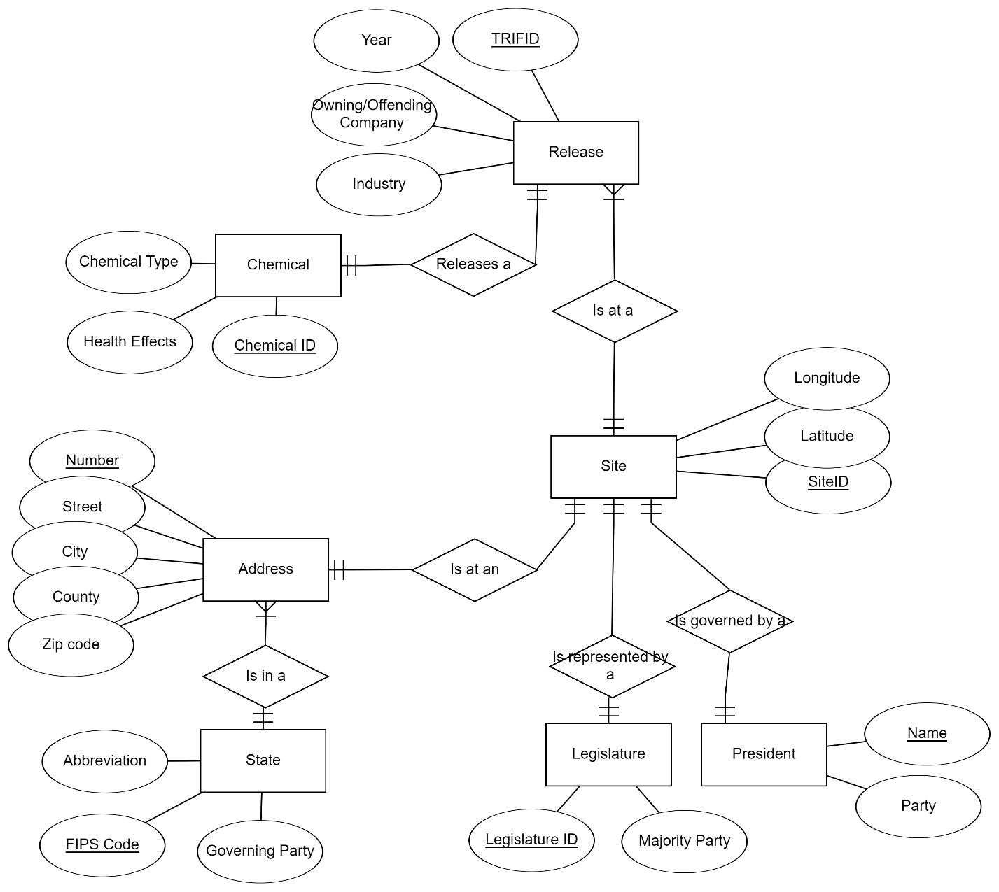

We transformed this into the following seven relational schemas:

**Release:**

* TRIID (integer, Primary Key): Identification number of Release
* Year (integer): Year in which Release occurred
* Owning/Offending Company (string): Company responsible for Release
* Industry (string): Industry in which Release occurred

**Chemical:**

* Chemical ID (integer, Primary Key): Identification number of Chemical
* Chemical Type (string): Name of Chemical involved in Release
* Health Effects (string): Health effects caused by Chemical.

**Address:**

* AddressNumber (integer, Primary Key): Unique ID which represents an address
* Street (string): Street where the spill occurred
* City (string): City where the spill occurred
* County (string): County where the spill occurred
* Zip Code (string): Zip code of where the spill occurred

**Site:**

* SiteID (integer, Primary Key): Identification number of Site
* Longitude (double): Location longitude value
* Latitude (double): Location latitude value

**State:**

* FIPS Code (integer, Primary Key): Identification code of State
* Governing Party (string): Political party of state’s governor

**Legislature:**

* Legislature ID (integer, Primary Key): Identification number of legislative body
* Majority Party (string): Political party with majority in legislature

**President:**

* Name (string, Primary Key): Name of President
* Party (string, Primary Key): Political party that President aligns with.

**SQL Table Creation**

The relations schemas in the previous section were successfully transformed into the following SQL create table commands:

These tables were then successfully created in our database which resulted in the following empty tables:

